Step 1 (From Task 2: Realign Fundraising Goals)

Apply the “Crisis Fundraising Assessment” to your own organization for your top 5-10 funding sources (e.g. Government, Foundations, Major Donors, Monthly Donors, etc.) by completing the chart below.

Organization’s Name
Fundraising Target Summary |  |  | Approved
 |  |  | Reassessed
Funding Source | Projected Revenue | Original Assumptions  (pre-pandemic) | Revised  Assumptions  (current) | Possible Actions Steps

Note: Should you have question about completing this Action Plan please email: clayton.rowe@saben.ca

Step 2 (From Task 3: Understand Donor Expectations)

Review the following checklist of important donor engagement resources (tools, initiatives, and systems). Check the boxes which apply to your organization

Key Elements | Tools, Initiatives, and Systems | Implemented  Pre-pandemic | Reviewed, Updated, or Created
Articulate Mandate | Statements of Values, Mission and Vision that shape our decision-making and communications
Report the Impact | Up-to-date cost/participant (or similar) calculations for our key programs
 | Key findings from recent program evaluations are easy for staff/stakeholders to access
 | Participant stories and community impact stats inform your public-facing communication platforms
Invite to Participate | Up-to-date Covid-19 Impact Messaging that is reflective of both our organizational strategy and how are participants are being affected
 | Covid-19 Messaging training to equip Board/Staff/Volunteers to reinforce our key themes
 | Communication/Engagement plans for each key stakeholder/donor group
Invest in Relationships | Up-to-date CRM system and clear procedures for implementation while working remotely
 | Offering specific opportunities for input from key stakeholders in light of Covid-19
 | Annual donor acknowledgement / gratitude plan
© The Saben Group

What specific action steps or research does this checklist lead you to consider for your own organization?
Action Steps

Step 3: (From Task 3: Understand Donor Expectations)

Evaluate how your organization has integrated these approaches into your pandemic-informed fundraising.

Donor Retention Good Practices | Strong | Average | Poor | N/A
Plan for thanking donors, including acknowledging donor’s giving history
Clear presentation of how donor funds are being spent and current need for funds
Regular opportunity for donors to express or update preferred method / frequency of communication
Plan for opportunities for engagement beyond financial investment
Pro-active management of organizational reputation in public sphere (e.g. media stories, endorsements from public figures)
Clear benchmarks for response time to donor questions or requests
Updates on innovation, learning and the organization’s strategic adaptation
Compelling project impact metric reporting

Capture 3-5 potential action steps based on the checklist above
Action Steps

Step 4: (From Task 4: Examine Online Fundraising Practices)

Evaluate how you have engaged “good practices” in your online crisis fundraising.
Engaging Online Fundraising | Implementation
 | Good | Average | Poor | N/A
Social Media Platforms
Promote engagement via Facebook
Post regular Instagram Stories
Produce media-friendly content: articles, podcasts, teaser videos
Generate updates for institutional donors and partners via Twitter / LinkedIn
Actively encourage communication via chatbot or website interaction platform
Facilitate creation of 3rd Party fundraisers (e.g. Facebook / GoFundMe / Fundly)
Livestream and/or produce regular video content
Email Communication
Welcome communication for new subscribers
User-friendly communication optimization process for stakeholders
Consistent email signature strategy for staff
Open, click-through and unsubscribe rates directly inform your email strategy and ongoing learning
Donation Options
Donation process optimized for both desktop and mobile
Consistent messaging across all donation portals (e.g. Canada Helps, EchoAge, Fundly)
Source: 2020 Nonprofit Communication Trends
Action Steps

Step 5: Prioritize Your Actions

Review your possible actions from steps 1 to 4. Choose 3-5 priorities you will complete in the next 60-Days. Write your priority action steps in the space below. Consider accomplishing priority action steps 1 and 2 before the end of July and priority action steps 3-5 before the end of August.

Action Step Priorities | Action Step Description | Before  July 31 | Before  August 31
Priority 1
Priority 2
Priority 3
Priority 4
Priority 5

Step 6: Create Work Plans

Create a work plan for each action step priority. See Annex C for an example for a completed work plan

Work Plan |  | Priority Action Step 1 |  |  |  |  | Date
 | Tasks |  |  | Who is responsible? | Who will support? | Who to consult? | By When? | Status
1
2
3
4
5
6
7
8
Key |  | On Target | Delayed |  | Cancelled |  | Completed

Work Plan |  | Priority Action Step 2 |  |  |  |  | Date
 | Tasks |  |  | Who is responsible? | Who will support? | Who to consult? | By When? | Status
1
2
3
4
5
6
7
8
Key |  | On Target | Delayed |  | Cancelled |  | Completed

Work Plan |  | Priority Action Step 3 |  |  |  |  | Date
 | Tasks |  |  | Who is responsible? | Who will support? | Who to consult? | By When? | Status
1
2
3
4
5
6
7
8
Key |  | On Target | Delayed |  | Cancelled |  | Completed

Work Plan |  | Priority Action Step 4 |  |  |  |  | Date
 | Tasks |  |  | Who is responsible? | Who will support? | Who to consult? | By When? | Status
1
2
3
4
5
6
7
8
Key |  | On Target | Delayed |  | Cancelled |  | Completed

Work Plan |  | Priority Action Step 5 |  |  |  |  | Date
 | Tasks |  |  | Who is responsible? | Who will support? | Who to consult? | By When? | Status
1
2
3
4
5
6
7
8
Key |  | On Target | Delayed |  | Cancelled |  | Completed

Please Note the additional resources in Annex:

- Annex A: Crisis Fundraising Assessment
- Annex B: 4 Elements of Resource Development
- Annex C: Work plan Example
Annex A: Crisis Fundraising Assessment Cycle

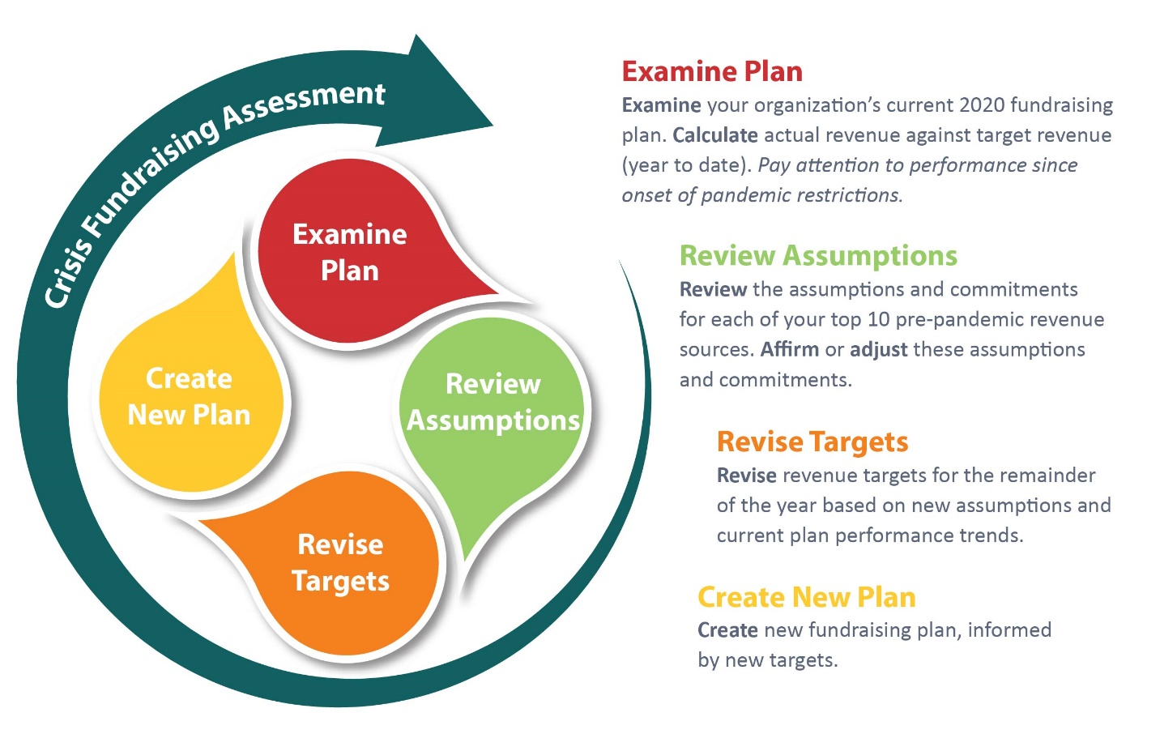
© The Saben Group

Annex B: 4 Elements of Resource Development

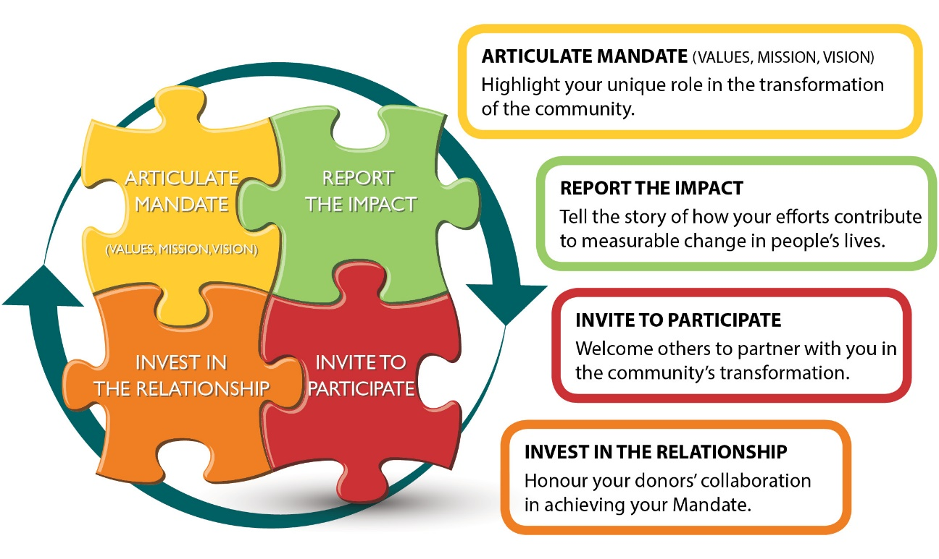
© The Saben Group

Annex C: Work Plan Example

Work Plan |  | Priority Action Step 5 | Volunteer Re-engagement |  |  |  | Date | June
 | Tasks |  |  | Who is responsible? | Who will support? | Who to consult? | By When? | Status
1 | Assess new volunteer opportunities during current crisis |  |  | John | Mary & Said | Leadership Team | June 3
2 | Develop volunteer profiles to connect to priority areas |  |  | Mary | Said | Department Managers | June 10
3 | Update Health and Safety protocols for staff and volunteers |  |  | Said |  | The City | June 15
4 | Create online training materials for volunteers |  |  | Carmena | Rachel | Said & Mary | June 20
5 | Send volunteer engagement communication update to all staff |  |  | ED | Rachel |  | June 22
6 | Send communication update to all volunteers |  |  | ED | Rachel |  | June 24
7 | Application deadline for new volunteers |  |  |  |  |  | June 30
8 | Hold volunteer training and orientation |  |  |  |  |  | July 7
9
10
Key |  | On Target | Delayed |  | Cancelled |  | Completed

